**EX001**

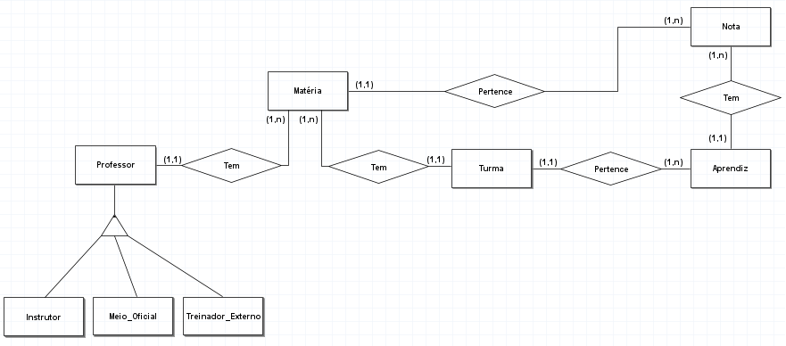

**EX002**

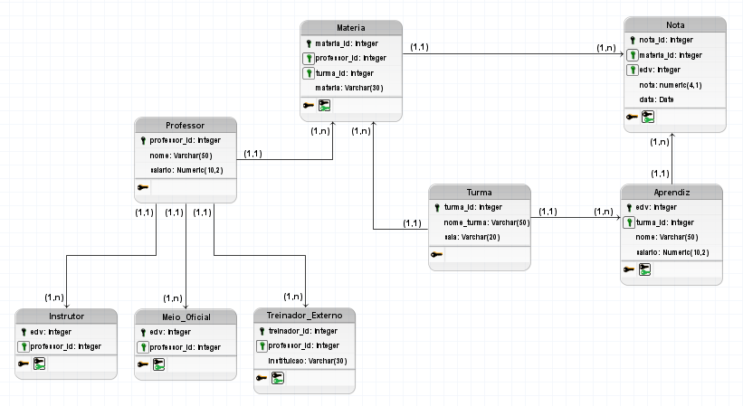

**EX003**

create database Prova;

use Prova;

create table Departamentos(

dep_id integer primary key identity(1,1),

dep_nome varchar(20) not null,

dep_local integer not null

);

create table Grade_salarial(

grade integer primary key identity(1,1),

sal_min integer not null,

sal_max integer not null

);

create table Funcionarios(

edv integer primary key,

nome varchar(30) not null,

lider varchar(15) not null,

data_de_contratacao date not null,

salario integer not null,

dep_id integer not null,

foreign key (dep_id) references Departamentos

);

insert into Departamentos(dep_nome, dep_local) values

('REMAN', 104),

('ICO', 101),

('ETS', 401),

('FCM', 303),

('INOVE', 303);

insert into Grade_salarial(sal_min, sal_max) values

(1500, 4000),

(4001, 9000),

(9001, 22000),

(22001, 50000);

insert into Funcionarios(edv,nome,lider,data_de_contratacao,salario,dep_id) values

(92890148,'Edna Carvalho','Andrea','1990-02-24',19000,1),

(92790062,'João Manfredo','Andrea','2001-09-26',12500,1),

(91004090,'Débora Junior','Andrea','1999-03-02',15600,1),

(94566222,'Carla Rodrigues','Andrea','1990-10-04',20000,1),

(96334100,'Maciel Oliveira','Andrea','1995-12-06',16500,1),

(97885245,'Guilherme Guilhermo','Marcos','2010-05-13',9000,2),

(92894706,'Jessica Lima','Marcos','2015-08-14',25678,2),

(91450032,'Isabella Machado','Marcos','1993-01-22',10900,2),

(94661932,'Carlo Daniel','Lucio','1990-01-31',13750,2),

(95780634,'Maria Santana','Lucio','2015-09-05',8000,2),

(97881945,'Dominic Ferreira','Pietra','2020-02-09',2000,3),

(98490620,'Daniela Silva','Pietra','2020-02-09',1500,3),

(96854299,'Felipe Augusto','Pietra','2020-02-09',1600,3),

(97805503,'Natalia Reis','Pietra','2019-06-14',2200,3),

(90103456,'Thiago Dias','Pietra','2018-08-24',2800,3),

(98462157,'Lorena Ray','Pietra','2017-02-25',1900,3),

(95482340,'Natanael Brasil','Pietra','2020-06-03',3500,3),

(96314782,'Ana Mass','Captu','1997-02-19',3600,4),

(97854318,'Otávio Luis','Captu','2017-05-19',9200,4),

(94862122,'Luisa Otávia','Captu','2002-11-11',10500,4),

(97864320,'Lucas Moura','Captu','1990-08-29',6600,4),

(96315782,'Fernanda Lacerda','Captu','1999-12-17',2900,4),

(97546210,'Caroline Adeus','Captu','2018-02-19',4555,4),

(94621573,'Marco Valastro','Captu','2003-03-30',7000,4),

(96548432,'Valdemir Cantante','Jonas','2020-03-15',1200,5),

(97511020,'Eduarda Souza','Jonas','2011-08-14',1100,5),

(96410654,'Allan Jonas','Felipe','2008-06-17',3200,5),

(95645012,'Diana Jones','Felipe','2002-09-24',2050,5),

(94746054,'Mario Bros','Felipe','1990-01-18',25600,5),

(92085478,'Aline Franco','Jonas','1996-05-05',3700,5);

**EX004**

select top 1 f.nome as Nome, d.dep_nome as Setor, f.salario as Salário

from Funcionarios as f

inner join Departamentos as d on f.dep_id = d.dep_id

where f.nome like 'D%'

order by f.salario desc;

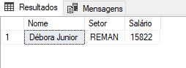

**EX005**

select f.nome as Nome, d.dep_nome as Nome_do_Departamento, d.dep_local as Local_de_Trabalho

from Funcionarios as f

inner join Departamentos as d on f.dep_id = d.dep_id;

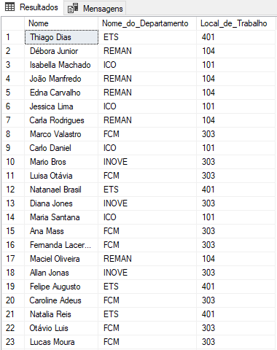

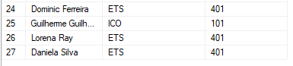

**EX006**

update Funcionarios

set salario = salario + ((select sum(salario) from Funcionarios where lider = 'Jonas') / (select count(salario) from funcionarios where lider <> 'Jonas'))

where lider <> 'Jonas';

delete from Funcionarios

where lider = 'Jonas';

select nome, lider, salario from Funcionarios;

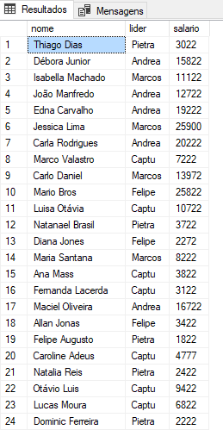

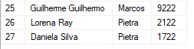

**EX007**

select nome as Nome, edv as EDV, lider as Líder,

(select grade from Grade_salarial as g

inner join Funcionarios as f on f.salario > g.sal_min and f.salario < g.sal_max

where f.data_de_contratacao = (select min(data_de_contratacao) from Funcionarios)) as Grade_Salarial

from Funcionarios

where data_de_contratacao = (select min(data_de_contratacao) from Funcionarios);

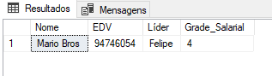

**EX008**

select d.dep_nome as Nome_do_Departamento, count(f.salario) as Salarios_Maior_Que_4000

from Departamentos as d

inner join Funcionarios as f on d.dep_id = f.dep_id

where f.salario > 4000

group by d.dep_nome;

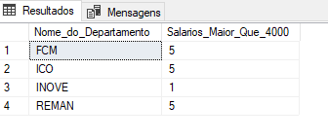

**EX009**

update Funcionarios

set lider = 'Marcos'

where lider = 'Lucio';

select nome, edv, data_de_contratacao

from Funcionarios

where lider in ('Marcos', 'Captu') and data_de_contratacao >= '01-01-2015';

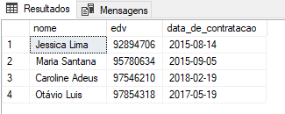

**EX010**

select d.dep_nome as Setor, avg(f.salario) as Média_Salário_Setor

from Departamentos as d

inner join Funcionarios as f on d.dep_id = f.dep_id

group by d.dep_nome;

select d.dep_nome as Setor, min(f.salario) as Menor_Salário_Setor, max(f.salario) as Maior_Salário_Setor

from Departamentos as d

inner join Funcionarios as f on d.dep_id = f.dep_id

group by d.dep_nome;

